# Table of Contents

Contents

Table of Contents 1

Important Links 2

SmartPac 3 wiki 2

SmartPac 5 wiki 2

1.16 - Gripper Adv/Ret Cycle Fault 3

Material Setup 4

Ultrasonic sensor version (for 3.x machines) 6

Kickout “The scanned box barcode is not valid” 7

HMI not showing data after update 8

ASIN Tote Supply conveyor empty and/or Machine Starved warnings on HMI 9

# Important Links

## SmartPac 3 wiki

* <https://w.amazon.com/index.php/FCShip/SmartPac>

## SmartPac 5 wiki

* <https://w.amazon.com/bin/view/FCShip/SmartPac/Version5_x/>

# 1.16 - Gripper Adv/Ret Cycle Fault

* Indicates the gripper advance (move to right) cylinder advance reed switch is not working
* It is suggested that this sensor be repaired
* If you choose not to repair the sensor, enable g_par.24

# Material Setup

Only the config for the material you are running should be active (ON).

Toggle the g_par bit to indicate the width of SmartPac film running on the machine, i.e. whether the machine is running **24” wide bubble film, 30” wide bubble film, 36” wide bubble film (g_par.13, g_par.14, g_par.15 respectively)** or if the machine is running **SmartPoly film (g_par.16)**.

NOTE: Only one bit out of g_par.13, g_par.14, g_par.15, g_par.16 will be active at any time.

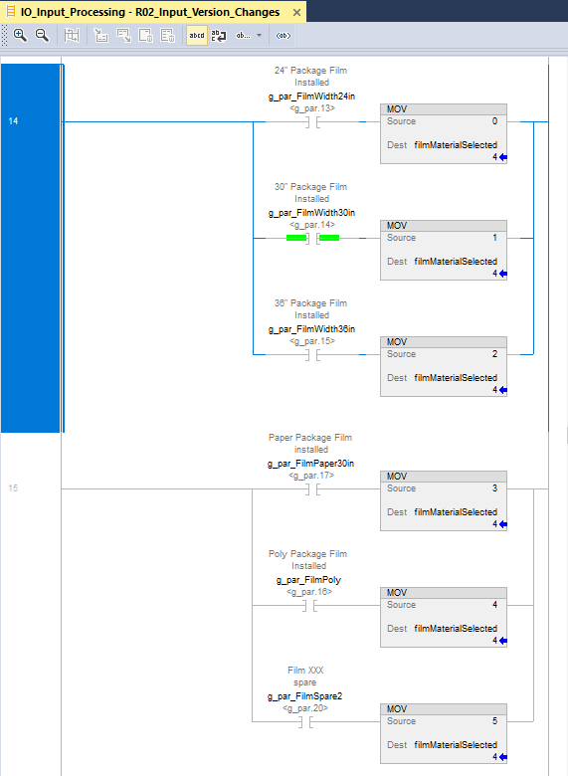

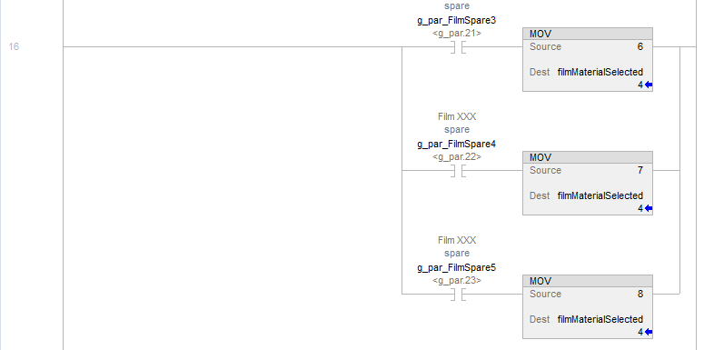

# Ultrasonic sensor version (for 3.x machines)

Toggle the g_par bit to indicate the IO Link version of ultrasonic sensor installed on the machine (g_par.18)

IO Link version 1.0 – Pico+25/WK/F, Pico+35/WK/F

IO Link version 1.1 – Pico+25/WK/F/A, Pico+35/WK/F/A

Front sensor model number (close to operator) : Pico+25/WK/F Rear sensor model number (away from operator): Pico+35/WK/F - IO Link version 1.0 **(g_par.18 ON)**

Front sensor model number (close to operator): Pico+25/WK/F/A Rear sensor model number (away from operator): Pico+35/WK/F/A – IO Link version 1.1 **(g_par.18 OFF)**

Note sensors have to be either both IO Link version 1.0 or both IO Link version 1.1.

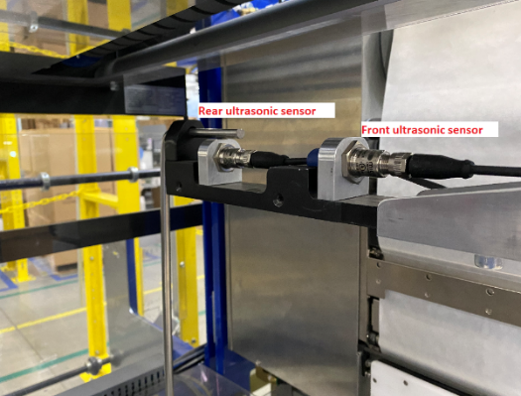

# Kickout “The scanned box barcode is not valid”

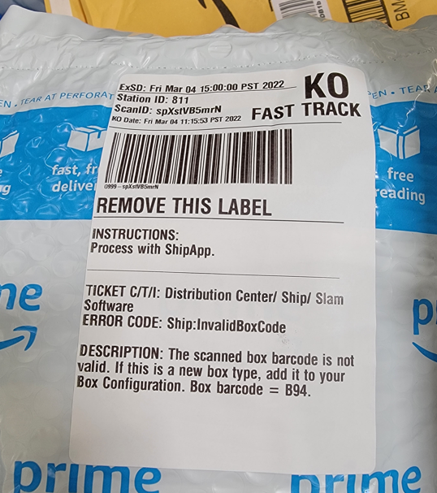

# HMI not showing data after update

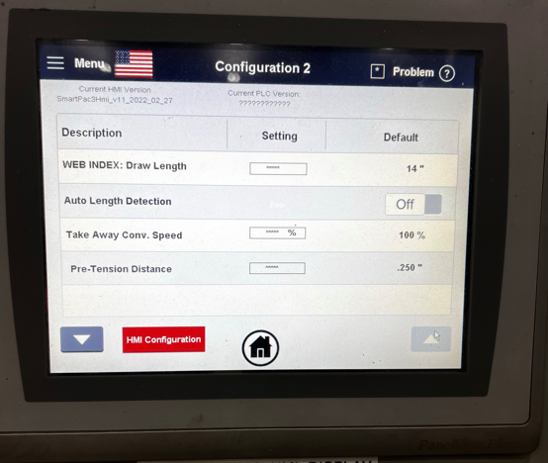

Update HMI firmware

<https://drive.corp.amazon.com/folders/SmartPac/Code%20Repository/02_HMI%20Code/SmartPac%203.x/firmware>

# ASIN Tote Supply conveyor empty and/or Machine Starved warnings on HMI

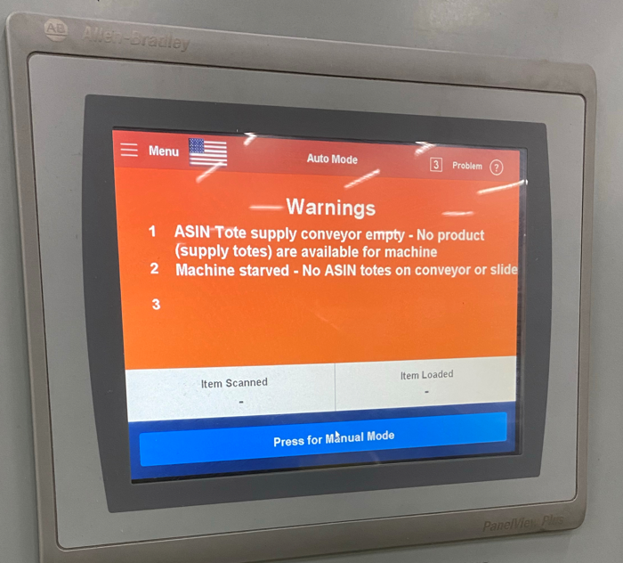

This is likely due to sensors being light activated vs dark activated.

* gPar.7 and gPar.8 allow inverting the sensor if needed. <https://w.amazon.com/index.php/FCShip/SmartPac#g_Par_Definitions_.28Machine_Option_Settings.29>
* Setup Information

<https://w.amazon.com/index.php/FCShip/SmartPac#OEE_Starved_Condition_Definition>